Worship at Home

Call to Worship

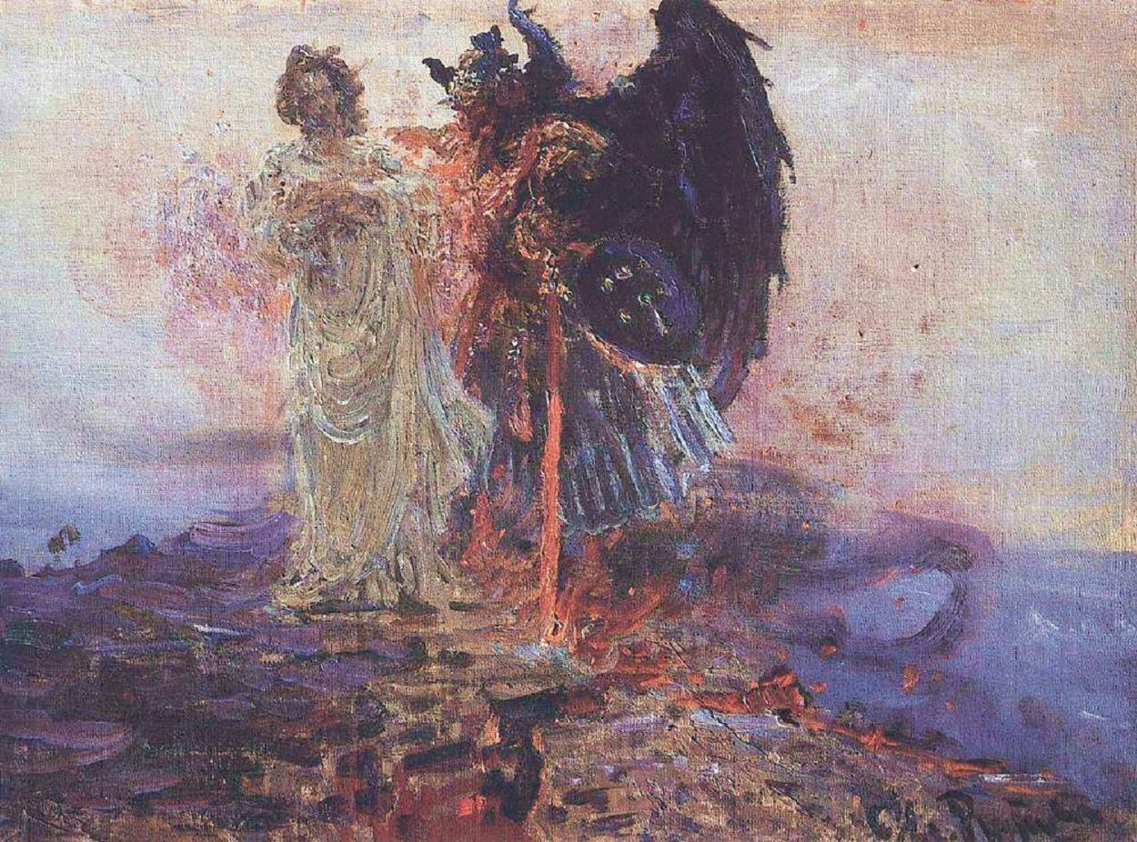
He is Lord, he is Lord! He is risen from the dead and he is Lord!
Get Behind Me, Satan.
Every knee shall bow, every tongue confess that Jesus Christ is Lord.

Welcome

Bowing before Jesus Christ displays faith. By faith the humble confess the power of Jesus Christ. The power of HIs name is displayed as He suffers, dies, and rises again. To those who caused his suffering he offers mercy. To those who receive mercy he promises, “Today, you will be with me in paradise. Those who enter paradise with him proclaim the message of Fatih with Him, “Father, into your hands I commit my spirit.”

See the change to take place in the Christian’s Life? Where we encounter suffering, and death we see Christ and him resurrected.

Confession

Acts of Humility: Tell the Lord about your suffering. Get specific. A friend, family member, neighbor, or enemy is likely involved. Name these folks. But humbly tell the Lord what you think about your present suffering. Humbly tell the Lord how you feel about your present suffering. Humbly give him your heart and mind. Notice that feelings and thoughts are spirits that cannot be touched or held like physical things.
To change fighting into peace let two fingers rise from your fist to form the “V.” Then sing, Victory in Jesus.

Tending the Tree of Knowledge of Good and Evil makes Peace. Eating the fruit of judgement creates evil. See Genesis 3:15-17

Robert.

Act of Mercy: Jesus suffered. He felt forsaken. Yet he gave the people creating his suffering mercy. Forgiveness changes our focus from bondage to freedom. Through your Acts of Humility you gave the Lord the suffering in your heart and mind. You committed the spirit of your heart and mind to God. Humility and Mercy are the building blocks of faith. Faith has little to do with what we know. Faith is WHO we trust to guide us in the Way to Truth that celebrates Life.

Acts of Thanksgiving: Give thanks that Jesus has empathy and compassion for you. Your suffering is like His suffering. Faith trusts Jesus with our thoughts and feelings about suffering. By faith we receive into our hearts and minds his mercy. Give thanks for the people involved in your suffering. Do this in remembrance of Christ on the Cross until you experience the change. When suffering dies it rises to new life. The new life is Peace. See the change is in you.

Acts of Witness: Find a person of Peace with whom to journey. Spend time each week telling the Person of Peace the Good News of Jesus Christ you experienced. Share the details of your Acts of Humility. Share the change of spirit that took place in your heart and mind once you received Christ’s Mercy. Then, invite the Person of Peace to share her or his Good News. The practice of Faith changes us. We change how we experience suffering. We change how we see ourself. We change how we see our neighbor.

Meditation

How would Trinity United Methodist Church change if everyone in attendance practiced the above Confession?

Hymn of Praise

It tells me of a Saviors love, who died to set me free; it tells of of His precious blood, the sinners perfect plea.
O how I love Jesus, O how I love Jesus, O how I love Jesus, because he first loved me.

Affirmation of Faith

How does scripture describe my belief changing into Faith in Christ?

“Finally, be strong in the Lord and in his mighty power. 11 Put on the full armor of God, so that you can take your stand against the devil’s schemes.”

Don’t we believe that Jesus defeated the devil? What change takes place when I stand against the devil?

12 For our struggle is not against flesh and blood, but against the rulers, against the authorities, against the powers of this dark world and against the spiritual forces of evil in the heavenly realms.

Why, then, do I believe I am in a constant battle with people. I see this battle taking place all around me. Look at the battle in politics, religion, families. Is scripture saying the Devil pit us against one another? I have questions and doubts. I need proof!

The Devil tempts us the same way he tempted Jesus. He tempted Jesus to doubt that God provides His physical needs. If you are Messiah turn these stones into bread. He tempted Jesus to prove he is the Messiah spoken of in Scripture. Faith has nothing to prove. Faith trusts in the Lord, not self, neighbor, institutions, nations…He tempted Jesus with earthly power by amassing physical things. Evil worships creation. Faith trust the Lord.

Scripture tells us the Devil’s ways. What does it say about Jesus’ ways.

13 Therefore put on the full armor of God, so that when the day of evil comes, you may be able to stand your ground, and after you have done everything, to stand.

Stand on faith in Christ. Where we encounter suffering, we hear Jesus cry, Father, forgive them they do not know what they are doing. Where we encounter death of relationships, institutions, powers and principalities we hear Jesus promise, “Today, you will be with me in paradise. Where we encounter the devil’s temptations, we are led by the same Spirit that taught Jesus to humbly say, “Father, into your hands I commit my spirit.”

Are you suggesting I can trust God with both good and evil?

Yes, sing with me, “Pardon for sin and a peace that endureth, thine own dear presence to cheer and to guide; strength for today and bright hope for tomorrow, blessings all mine with ten thousands beside.

Great is Thy Faithfulness! Great is Thy Faithfulness! Morning my morning new mercies I see; all I have needed thy hand hath provided; great is Thy faithfulness, Lord, unto me.

So faith is all about trusting God with the good and evil I see.

Faith trust mercy bears “pardon for sin.”
Faith trust Jesus’ Peace.
Faith trust that the Fruit of Jesus’ Peace changes every curse into a blessing.

Hear the Word: II Timothy

4 In the presence of God and of Christ Jesus, who will judge the living and the dead, and in view of his appearing and his kingdom, I give you this charge: 2 Preach the word; be prepared in season and out of season; correct, rebuke and encourage—with great patience and careful instruction. 3 For the time will come when people will not put up with sound doctrine. Instead, to suit their own desires, they will gather around them a great number of teachers to say what their itching ears want to hear. 4 They will turn their ears away from the truth and turn aside to myths. 5 But you, keep your head in all situations, endure hardship, do the work of an evangelist, discharge all the duties of your ministry.

Homily: Peace tends the Tree of Knowledge of Good and Evil.

We would do well to humble ourselves before Christ and hear Paul’s guidance.
- Preach the Word. He tells Timothy the way to preach.
  - Correct according to the word. For Paul the Word is The Good News of Jesus Christ revealed from the Cross.
  - Rebuke Satan, we are not in a battle with flesh and blood.
  - Encourage one another to tend to the Tree of Knowledge of Good and Evil. Faith tends to the Tree of Knowledge of Good and Evil. Eating its Fruit worships Satan, the Devil. The Fruit of Judgement leads to battles of flesh and blood.
  - Patience and careful instruction: Love is patient with suffering. Careful instruction refers to Pauls’ comprehension of “Sound Doctrine.”
What are the sound doctrines? In various places Paul is crystal clear about the sound doctrines. He calls these sound doctrines “Good News.” “The Son of man must Suffer, Die, and Rise Again.”
- See the following passages and listen to Paul proclaim his Faith in the Good News, Jesus suffered as we suffer. Mercy is the death of Suffering. Jesus rose again to life, Peace with God, self, and neighbor.
  - II Timothy 1: 6-13
  - Romans 1:1-6
  - II Corinthians 1:3-11

Friends, Paul saw a time when people would not put up with Sound Doctrine. It was happening in every place he preached. It still takes place today. Sadducees still insist those in Christ must submit to the Old Covenant given through Moses. Pharisees love to take he 613 laws of Moses and explain what each one really means. (Doctrines) By this they place works righteousness burdens on peoples hearts and minds that makes suffering even worse.

To “Correct”, I hear Paul echoing exactly what Jesus taught his Disciples. Look at Matthew 16: 15 and following.

“But what about you?” he asked. “Who do you say I am?”
16 Simon Peter answered, “You are the Messiah, the Son of the living God.”
17 Jesus replied, “Blessed are you, Simon son of Jonah, for this was not revealed to you by flesh and blood, but by my Father in heaven. 18 And I tell you that you are Peter,[b] and on this rock I will build my church, and the gates of Hades[c] will not overcome it. 19 I will give you the keys of the kingdom of heaven; whatever you bind on earth will be[d] bound in heaven, and whatever you loose on earth will be[e] loosed in heaven.” 20 Then he ordered his disciples not to tell anyone that he was the Messiah.
21 From that time on Jesus began to explain to his disciples that he must go to Jerusalem and suffer many things at the hands of the elders, the chief priests and the teachers of the law, and that he must be killed and on the third day be raised to life.
22 Peter took him aside and began to rebuke him. “Never, Lord!” he said. “This shall never happen to you!”
23 Jesus turned and said to Peter, “Get behind me, Satan! You are a stumbling block to me; you do not have in mind the concerns of God, but merely human concerns.”
Notice that Paul instructs Timothy to do exactly what Jesus did with Peter. Peter rebuked Jesus for sharing the Good News that he must suffer, die, and rise again. Jesus immediately discerned what was happening. Satan was up to his old tricks. Before Jesus could “correct” Peter he had to deal with Satan. Peter rebuked Jesus. Jesus rebuked Satan. “Get behind me, Satan.”
Surely we see that as long as Satan, the Devil, evil stands between us and Jesus we cannot focus on Christ.
In Matthew 4 we read that Jesus was led by the Holy Spirit to be tempted by Satan. Herein I see Satan’s character. Satan deceives us three ways. First, he tempts us to doubt that God provides our physical needs. If you are Messiah, turn these stones into bread. Doubt questions if God, Christ, can be trusted. Listen to doubt! “If God really loved me there would not be suffering. Second, he tempts us to demand proof that Jesus is who scripture reveals him to be. If you are Messiah prove to me what scripture says about you. Proof is the enemy of Faith! Third, he tempts us to see things, power, and control to be of more value than people.
As long as we choose to let Satan stand between us and Jesus Christ we will be tempted by Doubt, Proof, and Things to control by our lust for power.
Preach the Good News!
The Good News is that Jesus suffered. Satan will always flee in the presence suffering met with Mercy, that invites people to receive Grace, Christ’s Peace, and flows with unconditional love that reflects the image of God’s love revealed on the Cross through Jesus’ suffering, death, and resurrection. This is why Paul tells Timothy and us to Correct, Rebuke, and Encourage with Patience and careful instruction.
Correct doctrine teaches that Jesus suffered, died, and rose again.
Rebuke Satan, not you neighbor. Rebuke Satan by tending to the Tree of Knowledge of Good and Evil with mercy, grace, and love.
Encourage one another as Jesus encouraged Peter. Peter had his mind set on earthy things. Jesus encouraged him to look at life through heavenly things. What are the heavenly things of which Jesus speaks. Jesus calls suffering, death, and resurrection the keys to the Kingdom of Heaven.
The change to take place in the Christian life is to become like Christ. Where we see suffering we offer mercy. Where we see the death of earthly things like institutions, traditions, powers, and principalities we see the hope of people united in God’s Grace. Where we see signs of new life emerging, we celebrate Peace.
The Peace of Christ tends to the Tree of Knowledge of Good and Evil. Satan tempts us to lose Christ’s peace through Doubt, Proof, and making physical things more important than mercy, grace and love.
In John’s Gospel Jesus saw Nathaniel still sitting beneath the fig tree. Nathaniel was tending to the Tree of Knowledge of Good and Evil. He wasn’t picking and eating its fruit.
Peace be with you as you tend to the Tree of Knowledge of Good and Evil. When you eat the fruit and sow seed of judgement and condemnation remember Christ and patiently return to sound doctrines. Amen.

